Declaration of the European

Textile and Clothing Federations

Ultra-fast fashion:
European textile and clothing federations call for urgent action

The European textile and clothing federations are deeply concerned about the rise of ultra-fast fashion, which already accounts for around 5% of sales (20% on the internet) and is growing fast, with 4.5 billion parcels imported into the European Union in 2024.
Ultra-fast fashion is exacerbating environmental, economic and social imbalances:
- They generate an overproduction of clothes with an extremely short lifespan, leading to an unprecedented increase in textile waste and clothing consumption.
- They put unbearable pressure on European businesses, particularly SMEs, which strive to meet high environmental, ethical and social standards.
- They threaten shops in all the EU's cities, accelerating the depopulation of town centres.
Furthermore, ultra-fast fashion is based on an economic model that contravenes the rules in force in the European Union and its Member States. Amongst others, VAT fraud, violation of intellectual property rights, and misleading claims are recurring issues in ultra-fast fashion which fuel unfair competition within the Single Market, disadvantaging businesses that follow the EU’s high social and environmental standards.
Indeed, its profitability is based on the exploitation of a workforce in unacceptable conditions, complete disregard for any environmental consideration, VAT and customs duty fraud, the violation of intellectual property rights, allegations of unfair competition, and the exploitation of the environment.
In view of these developments, we solemnly and firmly call on:
1. The Member States of the European Union to adopt measures to limit the marketing of ultra-express fashion products and to actively support companies that invest in sustainability, quality and innovation.
2. The European institutions and the Member States to make the fight against ultra-fast fashion one of their priorities, working without delay to:
o Immediately implement the reform of the European Customs Code, the principles of which were agreed at the European Council of 27 June 2025,
o Speed up current investigations and adopt the toughest penalties under the DSA (Digital Services Act) and DMA(Digital Markets Act) to re-establish the conditions for fair competition,
o Introduce a tax on small parcels to finance customs controls,
o Abolish the exemption from customs duties for parcels of less than €150,
o Recover VAT on ultra-express mode shipments,
o Enter into dialogue with Chinese authorities on these platforms whose practices contradict their environmental objectives.
3. European consumers to favour sustainable products and support companies and brands committed to a responsible transition in the textile and clothing sector.
The European Union has the means and the duty to act immediately to strengthen the competitiveness of European companies and thus their employees and thereby protect the environment.
Ultra-express fashion cannot become the norm. It is time to act collectively to promote an economic model based on quality, transparency and social and environmental responsibility.
Signed in Villepinte, on the occasion of the Première Vision show, 16 September 2025
The European textile and clothing federations

 |  | 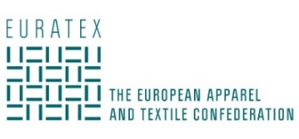
Lionel Guérin et Pierre-François Le Louët  Co-Presidents | Olivier Ducatillion  President | Mario Jorge Machado  President

  Associaçāo Têxtil e Vestuário  de Portugal | 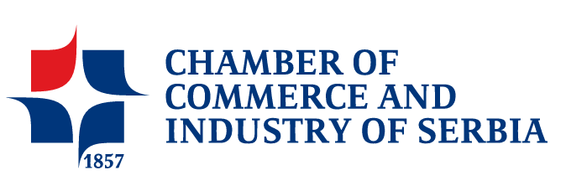 | 
Mario Jorge Machado  President | Sava Mitrovic  President | Luca Sburlati  President

 | 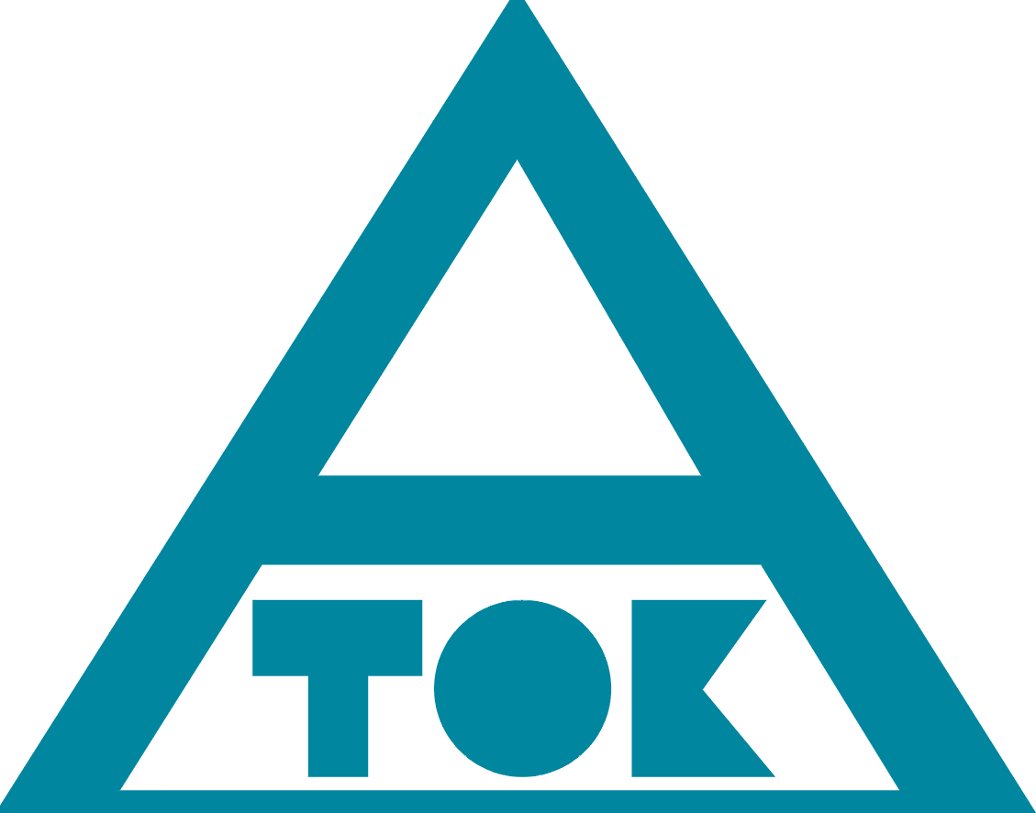 | 
Marja-Liisa Permikangas  General Manager | Robert SIMEK  Vice-President | Sylvia Roelofs  President

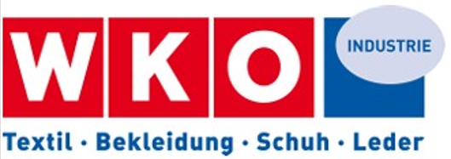  FACHVERBAND DER TEXTIL-, BEKLEIDUNGS-, SCHUH- UND LEDERINDUSTRIE | 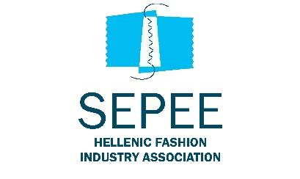 |   LITUANIAN APPAREL & TEXTILE INDUSTRY ASSOCIATION
Mag Eva Maria Strasser  Managing Director | Vassilis Masselos  President | Gyte Bekstiene
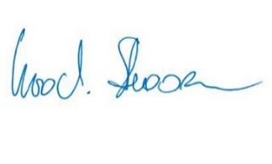 | 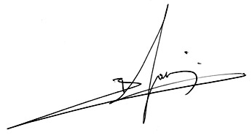

 | 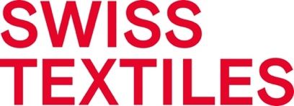 | 
Thomas Klausen  Chief executive officer | Peter Flückiger  Managing Director | Josep Maria Mestres  President
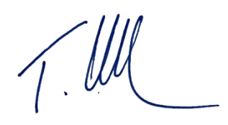 | 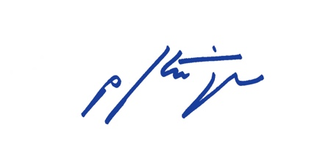

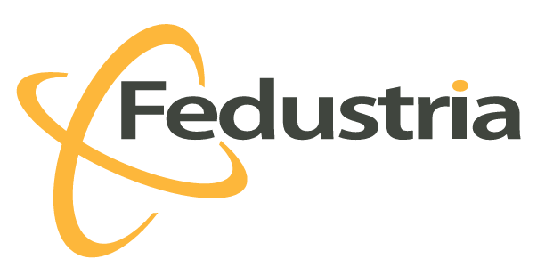 |  | 
Elizabeth De Wandeler  Advisor Economic Affairs | Ralph Kamphöner  Head of Brussels Office | César Araujo  President

 | 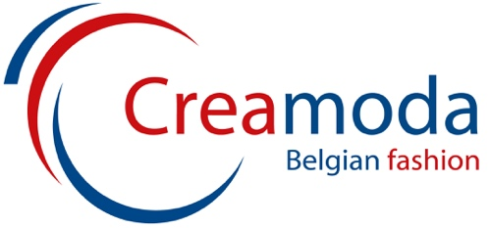 | 
Cecilia Nykvist  CEO | Erik Magnus  Managing Director | Bart Depourcq  President
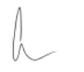 | Erik Magnus

Tadeusz Wawrzyniak
President

